Top 20 Basic Commands with Use Cases and Exercises

While there are many commands across different operating systems and applications, here are 20 basic commands commonly found on computers:

**1. dir (Windows) / ls (Linux/macOS):** Lists the contents of a directory.

**Use Case:** You want to see all the files and folders in your current location.

**Exercise:** Open a terminal window (Command Prompt on Windows, Terminal on macOS/Linux) and type dir (Windows) or ls (Linux/macOS). Press Enter.

**2. cd (all):** Changes the current directory.

**Use Case:** You want to navigate to a different folder on your computer.

**Exercise:** Try cd Desktop (Windows/Linux/macOS) to navigate to your Desktop folder. Then use dir (Windows) or ls (Linux/macOS) to see the contents.

**3. mkdir (all):** Creates a new directory.

**Use Case:** You want to organize your files by creating a new folder.

**Exercise:** Use mkdir Documents (Windows/Linux/macOS) to create a new folder named "Documents". Then use dir (Windows) or ls (Linux/macOS) to see if it's there.

**4. rm (Linux/macOS) / del (Windows):** Deletes a file or directory (use with caution!).

**Use Case:** You want to remove an unwanted file or folder.

**Exercise:** Important: Never delete anything critical! In a safe space (like a temporary folder), create a text file named "test.txt" and then use rm test.txt (Linux/macOS) or del test.txt (Windows) to delete it.

**5. copy (Windows) / cp (Linux/macOS):** Copies a file.

**Use Case:** You want to duplicate a file to another location.

**Exercise:** Create another text file named "test2.txt". Use copy test.txt test2.txt (Windows) or cp test.txt test2.txt (Linux/macOS) to copy "test.txt" as "test2.txt".

**6. move (Windows) / mv (Linux/macOS):** Moves a file from one location to another.

**Use Case:** You want to organize your files by moving them to a different folder.

**Exercise:** Use move test2.txt Documents (Windows) or mv test2.txt Documents (Linux/macOS) to move "test2.txt" to the "Documents" folder (assuming it exists).

**7. rename (Windows) / mv (Linux/macOS):** Renames a file.

**Use Case:** You want to give a file a different name.

**Exercise:** Use rename test.txt newname.txt (Windows) or mv test.txt newname.txt (Linux/macOS) to rename "test.txt" to "newname.txt".

**8. ping (all):** Checks if another computer is reachable on a network.

**Use Case:** You want to see if you can connect to a website or another device.

**Exercise:** Use ping google.com (all) to see if you can reach Google's servers.

**9. ipconfig (Windows) / ifconfig (Linux/macOS):** Shows network configuration information.

**Use Case:** You want to troubleshoot network connectivity issues.

**Exercise:** Use ipconfig (Windows) or ifconfig (Linux/macOS) to see your IP address and other network details.

**10. help (all):** Provides help information for other commands.

**Use Case:** You're unsure about how to use a specific command.

**Exercise:** If you're stuck on command like mv, type help mv (all) to see a manual page with usage information.

**11. clear (all):** Clears the screen (text) in the terminal window.

**Use Case:** Your terminal window is cluttered with previous commands, and you want a clean slate.

**Exercise:** Type clear (all) to clear the screen.

**12. date (all):** Shows the current date and time.

**Use Case:** You need to know the current date and time.

**Exercise:** Type date (all) to see the current date and time.

**Write a command using ls to list all files (including hidden files) in the current directory and its subdirectories.**

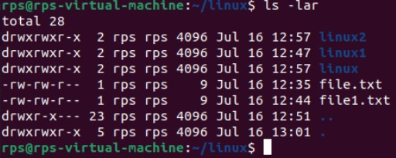

**Command:** ls -lar

**Modify the previous command to display only files with a specific extension (e.g., .txt).**

**Enhance the report by including the file size for each listed file.**

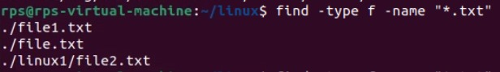

**Command:** find -type f -name “*.txt”

**Further refine the output to display only files modified within the last 24 hours.**

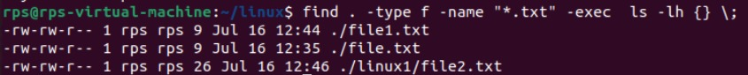

**Command:** find . -type f – name “*.txt” -exec ls -lh {} \;

**Combine the functionalities from points 2 and 4 to list only files with a specific extension (e.g., .jpg) modified in the last day.**

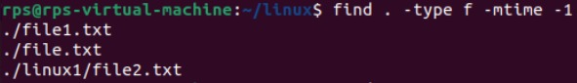

**Command:** find . -type f -mtime -1

**1.dir / ls (5):**

**Use dir / ls to list all files and folders in your current directory. How many files are there? (Excluding hidden files if applicable)**

**A:** ls – l: list all files and folders in your current directory

ls -l | grep -v '^d' | wc –l: To count the number of files (excluding directories)

**Utilize dir / ls with appropriate flags to display only files with a specific extension (e.g., .txt). How many files of that type exist?**

**A:** ls -l *.txt - Lists all .txt files in the current directory in long format.

ls -l *.txt | wc –l - Counts the number of lines, giving the number of .txt files

**Navigate to your Downloads folder using cd. Then, use dir / ls to list the contents. Are there any recently downloaded files (modified today)?**

**A:** cd ~/Downloads

ls -l

**Use dir / ls with flags to display both the filename and its size for each file in your current directory. Identify the largest file.**

**A:** ls -l *.docx

**1.dir / ls (5):**

Use dir / ls to list all files and folders in your current directory. How many files are there? (Excluding hidden files if applicable)

**A: ls – l**: list all files and folders in your current directory

**ls -l | grep -v '^d' | wc –l:** To count the number of files (excluding directories)

Utilize dir / ls with appropriate flags to display only files with a specific extension (e.g., .txt). How many files of that type exist?

**A: ls -l *.txt -** Lists all .txt files in the current directory in long format.

**ls -l *.txt | wc –l -** Counts the number of lines, giving the number of .txt files

Navigate to your Downloads folder using cd. Then, use dir / ls to list the contents. Are there any recently downloaded files (modified today)?

**A**: **cd ~/Downloads**

**ls -l**

Use dir / ls with flags to display both the filename and its size for each file in your current directory. Identify the largest file.

**A: ls -l *.docx**

Practice using dir / ls with wildcards (e.g., dir *.docx) to list all files with a specific extension pattern (e.g., all Word documents).

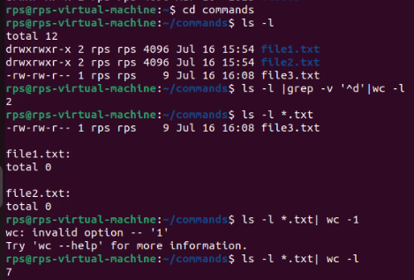

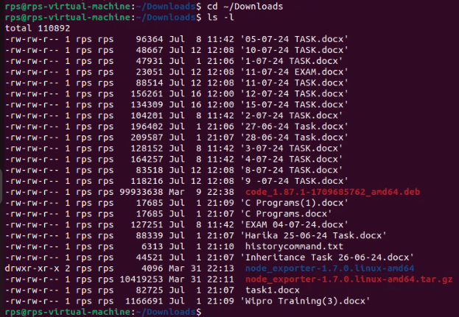

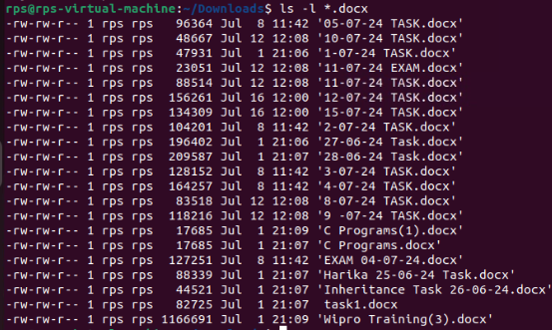

**2. cd (5):**

Use cd to navigate to your Documents folder. What is the full path of your Documents folder displayed by the prompt?

**A: cd ~/Documents :** Changes the directory to your Documents folder.

**Pwd:** Prints the full path of the current directory.

Practice using cd .. to move back one directory level from your current location.

**A: cd .. :** Moves up one directory level.

**Pwd :** Prints the full path of the current directory after moving up.

Utilize pwd to display the full path of the current directory after navigating with cd.

**A: cd ~/Documents**

**pwd**

Explore using directory shortcuts (e.g., ~ for home directory) with cd to quickly reach specific locations.

**A: cd ~**

**pwd**

Combine cd with dir / ls to navigate to a specific folder and then list its contents.

**A: cd ~/Documents**

**ls –l**

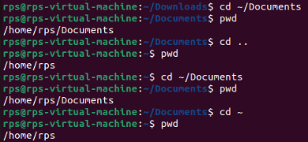

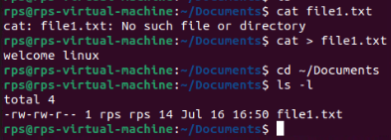

**-----------------------------------------------------------------------------------------------------------------------------------------**

**3.cp / mv (5):**

**Identify a file on your Desktop. Use cp to copy that file to your Documents folder. Verify the copy exists in Documents.**

**A: cp ~/Desktop/example.txt ~/Documents/ :** Copies example.txt from the Desktop to the Documents folder.

**ls ~/Documents/ :** Lists the contents of the Documents folder to verify the copy.

**Practice renaming a file on your Desktop using mv. Give it a new name and confirm the change using dir / ls.**

**A: mv ~/Desktop/example.txt ~/Desktop/example_renamed.txt:** Renames example.txt to example_renamed.txt on the Desktop.

**ls ~/Desktop/ :** Lists the contents of the Desktop to confirm the change.

**Locate a folder containing images. Use cp to copy a specific image file from that folder to another folder.**

**A: cp ~/Pictures/image.jpg ~/Documents/ :** Copies image.jpg from the Pictures folder to the Documents folder.

**ls ~/Documents/ :** Lists the contents of the Documents folder to verify the copy.

**Explore using mv to move a folder containing documents to a different location within your file system.**

**Try copying a file that already exists in the destination folder. What happens? (Experiment with different flags for cp if applicable on your system)**

**A:** mv ~/Documents/project ~/Work/

ls ~/Work/

**------------------------------------------------------------------------------------------------------------------------------------------**

**4. mkdir / rmdir (5):**

**Create a new folder named "Project Reports" inside your Documents folder using mkdir. Verify its existence using dir / ls.**

**A:** mkdir ~/Documents/"Project Reports"

**ls ~/Documents/**

**Practice using mkdir with multiple arguments to create a nested folder structure (e.g., mkdir Documents/ProjectX/Reports).**

**A:** mkdir -p ~/Documents/ProjectX/Reports

**ls ~/Documents/ProjectX**

**Locate an empty folder you created earlier. Use rmdir to delete it. Confirm its removal with dir / ls.**

**A:** mkdir ~/Documents/EmptyFolder

**Then, delete it using rmdir and confirm its removal:**

rmdir ~/Documents/EmptyFolder

**ls ~/Documents/**

**Explore using dir / ls to identify empty folders within a specific directory.**

**A:** find ~/Documents -type d -empty